**Getting API Keys and Tokens for Twitter**

To link to the twitter API you need four keys; the consumer key, consumer secret, access token and access token secret. To obtain these you will need to follow the following steps.

Go to <https://apps.twitter.com/app/new> either log in to your existing account or I would recommend that you set up a new account using your university email to keep this separate from your personal twitter account. If you set up a new twitter you will need to verify the account with an email address.

Once you have your account set up click on the same link <https://apps.twitter.com/app/new>. This should now automatically log you in to the developer page.

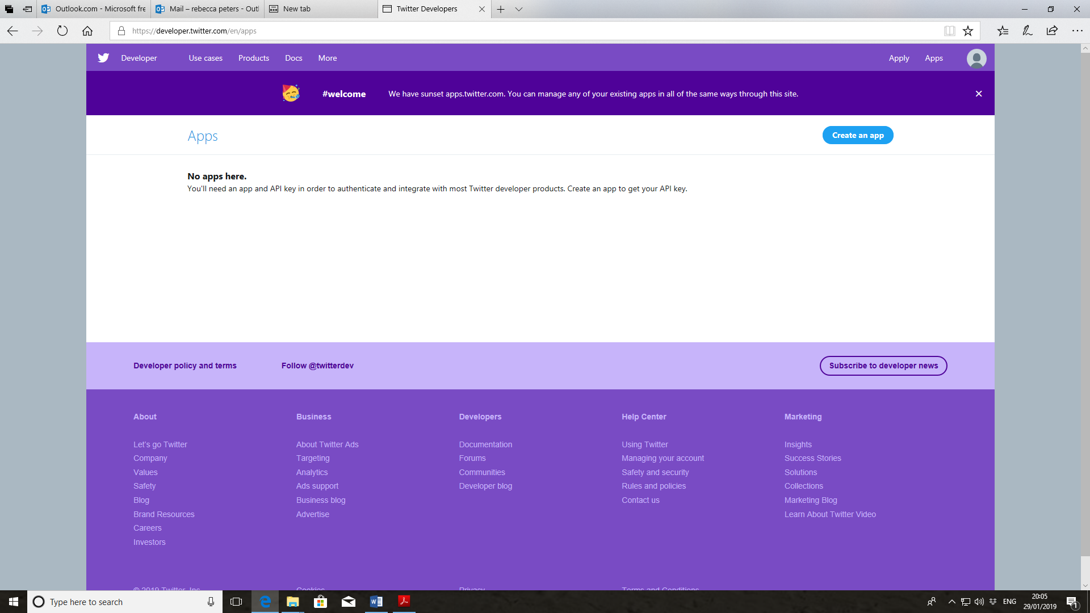

Click on Create an app

Apply for the developer account:

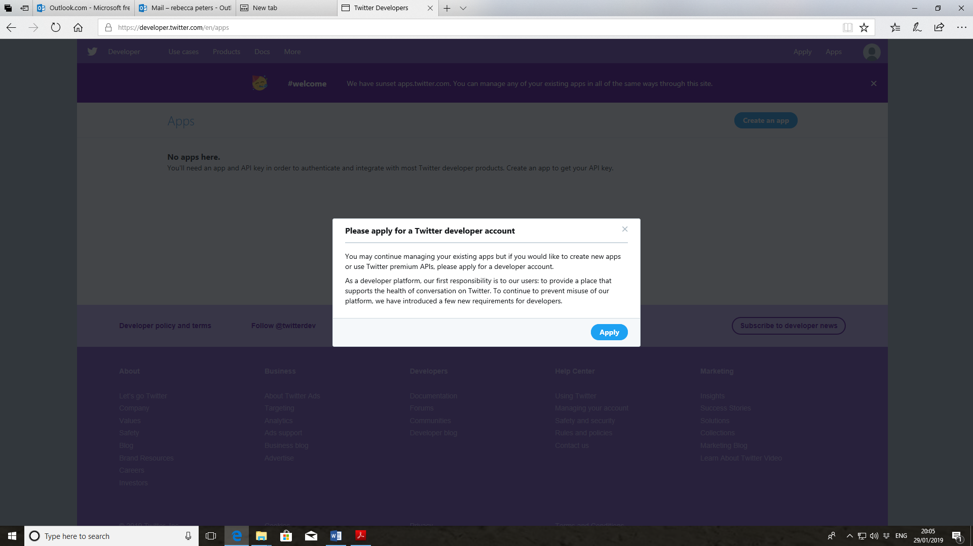

You will first need to select that you are a student and may need to verify your details.

Then you will need to enter a statement that should say something along the lines of, you are a student looking to analyse Twitter data as part of your education etc. This needs to be 200 characters.

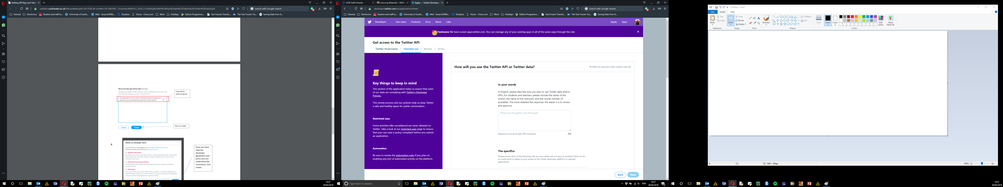

In the specifics, the first 2 boxes should be yes and you will need to enter the same statement as above.

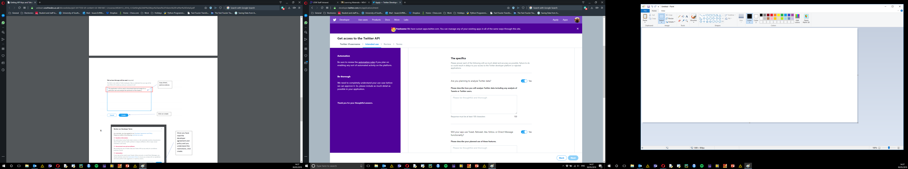

The remaining boxes should be set to no.

You will then be prompted to confirm your email address to finalise the set up of your account. You will then need to accept the developer agreement and wait for email confirmation.

This will then lead you back to twitter where you can now select to create an app. You will need to set a unique name. Try USW_Twitter_StudentNo.

You will then be able to see your keys. Please copy and save this in a document as we will need them in the lecture later.

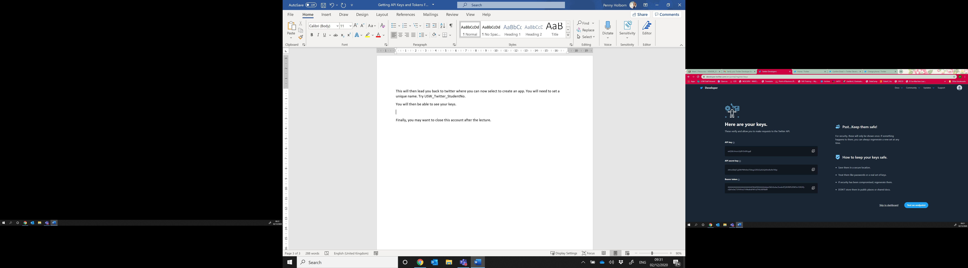

Finally, you may want to close this account after the lecture.